# How DataEditR works

It’s super-simple. Just run this code to:

1. **Load Libraries:** Load DataEditR , tidyverse and tidyquant.
2. **Import Data:** We’re using the mpg dataset that comes with ggplot2.
3. **Start Data Editing:** Use the data_edit() function.

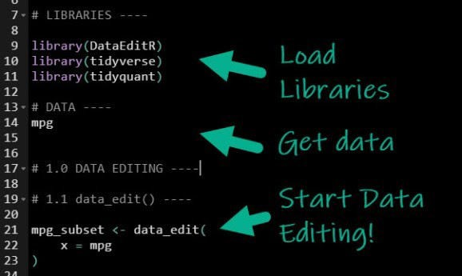

This launches the **Data Editor.**

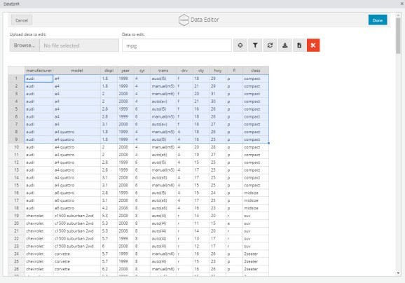

The Data Editor

## Try Editing Cells

Click on a cell and make any edits.

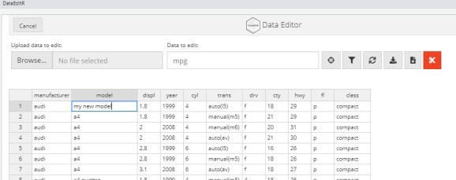

Editing Cells

## Try Selecting Columns

Click the target icon. Then select columns you are interested in.

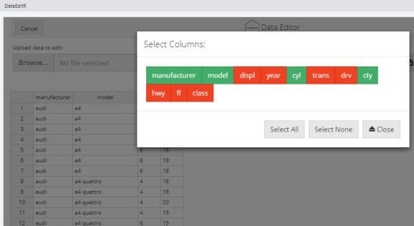

Selecting Columns

## When you’re done, save a CSV

After you’ve made your edits, you can optionally save a CSV File. Alternatively, you can return a data frame in your active R Session.

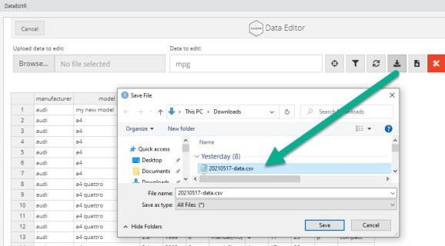

Save as CSV File

## Going Further

**with dplyr and ggplot2**

DataEditR is great for making simple edits. But, eventually you’re going to need to go further by using code to wrangle data and prepare visualizations.

**Fuel Economy by Vehicle Model**

Say that you wanted to make a visualization that shows the differences in vehicle models and their fuel economy measured as miles per gallon (MPG). We can do this with dplyr and ggplot2.

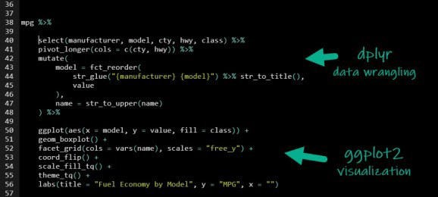

## Visualization and Insights

The code makes a stunning ggplot2 visualization that highlights the differences in fuel economy by vehicle model and class. We can see:

**SUV’s** clearly have the lowest fuel economy although the Subaru Forester AWD seems to be an outlier.

**Toyota Corolla** is leading the pack with Highway MPG in the mid-30s.

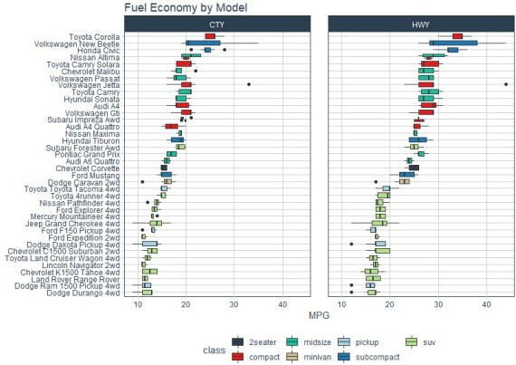

# In Summary

You’ve seen how DataEditR can be used for making simple edits inside of R. You’ve also seen that learning dplyr and ggplot2 can generate insights through visualizations.

What if you want to go further? Read on.